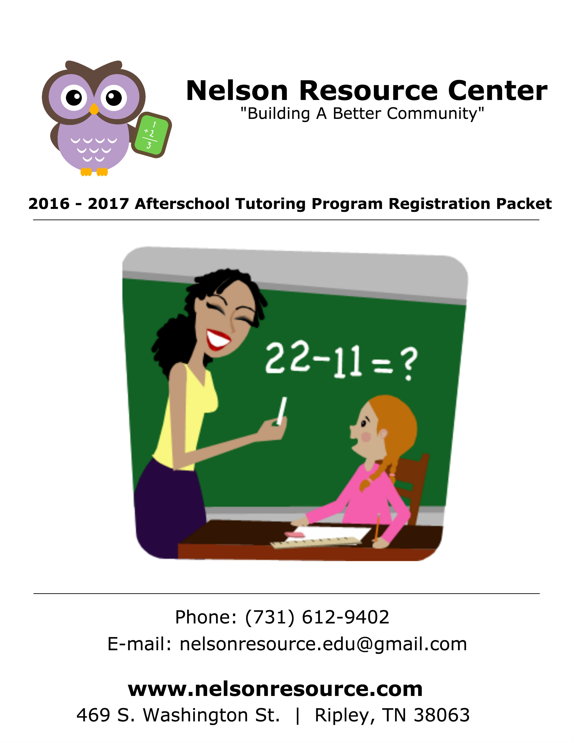

2016 - 2017 Afterschool Tutoring Program | Registration (1)
The 2016 – 2017 Afterschool Tutoring Program will begin Tuesday, September 6, 2016. The program is for students in grades 2nd – 9th. In order for your child to attend, this registration packet must be signed and turned in to the Nelson Resource Center along with the registration fee of $10, which will cover supplies and other materials.
Student Information
Child’s Name_______________________ Child’s Birth Date____________ Age______
Grade (entering 2016 – 2017) ________ Male_______ Female_________
School (Upcoming school year) ______________________________________________

Parent/Guardian Information
If there are custody issues involved with your child, you must provide the Program Directors with full court papers indicating who has permission to pick up the child. The program may not deny a parent access to his/her child without proper documentation.

Name _____________________________________ Name ____________________________________
Address __________________________________ Address __________________________________
_____________________________________________ ____________________________________________
Relationship_____________________________ Relationship_____________________________
D.O.B. ____________________________________ D.O.B. ____________________________________
Phone #1________________________________ Phone #1________________________________
Phone #2________________________________ Phone #2________________________________
Work____________________________________ Work_____________________________________

Authorized Persons to Pick Up Child
Your child will only be released to a parent/guardian or persons listed in this section.
Name ____________________________________ Relationship ____________________________________
Name ____________________________________ Relationship ____________________________________
Name ____________________________________ Relationship ____________________________________
Name ____________________________________ Relationship ____________________________________
2016 - 2017 Afterschool Tutoring Program | Registration (2)
Fees
A $10 registration fee is required for all students to enter the program. This fee guarantees your child a spot in the program and covers items like supplies, print outs, and other material students may need to use related to their schoolwork.

Weekly Fees
1 Child - $25/week
2 Children - $40/week
3 or more - $50/week

Drop-Ins
Drop-ins are welcome for a fee of $10 per child/per day. (Parents must register students before they can attend as a drop-in)

Important:
- Parents must register before students are able to attend the afterschool program. This includes drop-ins as well.
- Parents are responsible for communicating with their child’s school about transportation to the center.
- All fees have to be paid before any child can attend the program. Fees are due by Monday each week. (For the upcoming week).

--------------------------------------------------------------------------------------------
Transportation:
How will your child be transported to the center? (Please choose from the following):
__________ Car rider __________ Bus rider __________ Walker

__________ Other:

2016 - 2017 Afterschool Tutoring Program | Registration (3)

Emergency Contact:
Parents cannot be listed as emergency contacts. List the name of at least one person who can be contacted in the event of an emergency or illness if you cannot be reached. Any person listed should be able to assist in contacting you. At least one person listed must be able to take responsibility for the child in case the parent/guardian cannot be contacted and should be at least 18 years of age.
Contact#1 _______________________________ Relationship ____________________________________
Address__________________________________ Phone____________________________________________

Contact#2 _______________________________ Relationship ____________________________________
Address__________________________________ Phone____________________________________________

Name of Physician/Clinic/Hospital________________________________________________
Phone_________________________________________________________________________________
--------------------------------------------------------------------------------------------
Health
If your child takes medication please notify our staff (send a note) of the details. The Nelson Resource Center staff has the authority to refuse any child that may show signs of any contagious illness. In such cases, the judgment of the staff is final and refusal to come pick up the child will result in dismissal from the program.

If your child had a fever, they must be fever free for 24 hours in order to return to the program. Staff also has the authority to request that you provide a note from your child's doctor stating that the child is able to safely return to the program.

Please explain any allergies or other medical issues that your child may have:

_________________________________________________________________________________________________
2016 - 2017 Afterschool Tutoring Program | Registration (4)
Code of Conduct
Students are expected to exhibit appropriate behavior at all times.
Students shall:
1. Show respect to participants/staff, and take directions from all staff.
2. Refrain from aggressive behavior and using abusive or foul language.
3. Refrain from causing bodily harm to self, other participants, or staff.
4. Show respect to equipment, supplies, and facilities.
Students who do not conform to these rules risk extended time outs, removal from class into the office, suspension, or dismissal from the program.

Disciplinary Action
The 2016 – 2017 Afterschool Tutoring Program will follow a progressive form of discipline as outlined below, when deemed appropriate:
Written or Verbal Warning: Staff will discuss with the parent/guardian the undesirable conduct and why the action is not appropriate. If the action continues, a meeting will be held with the parent to try and resolve the situation prior to suspension.
Suspension: Staff may temporarily ban a participant from a number of activities, games, practices, facility or programs. (The length of the suspension will be determined by the severity of the action).
Dismissal: If inappropriate behavior persists or the behavior completely disrupts a program, removal from the program, facility or activity may be necessary.
**Refunds will not be given.

2016 - 2017 Afterschool Tutoring Program | Registration (5)
Please read carefully and respond to the Following Permission Forms

Registration/Weekly Fees:
I understand that my child must be registered before they can officially enter the program and that all fees must be paid by Monday of each week before my child can attend the program for that week. In the event that a child shows up and fees have not been paid, a staff member will have to call for someone to pick them up immediately.

Parent/Guardian Signature__________________________________________ Date_________________

--------------------------------------------------------------------------------------------

Photograph/Video Consent:
__________I give permission for my child, ______________________________________, to be in photographs or videos for use on our website or other media sources.
Parent/Guardian Signature______________________________________________ Date_____________

__________I do not give permission for my child, _______________________________________, to be in photographs or videos for use on our website or other media sources.
Parent/Guardian Signature______________________________________________ Date__________

